

page1image28575568

Database Systems

5COSC008C.1

Part A

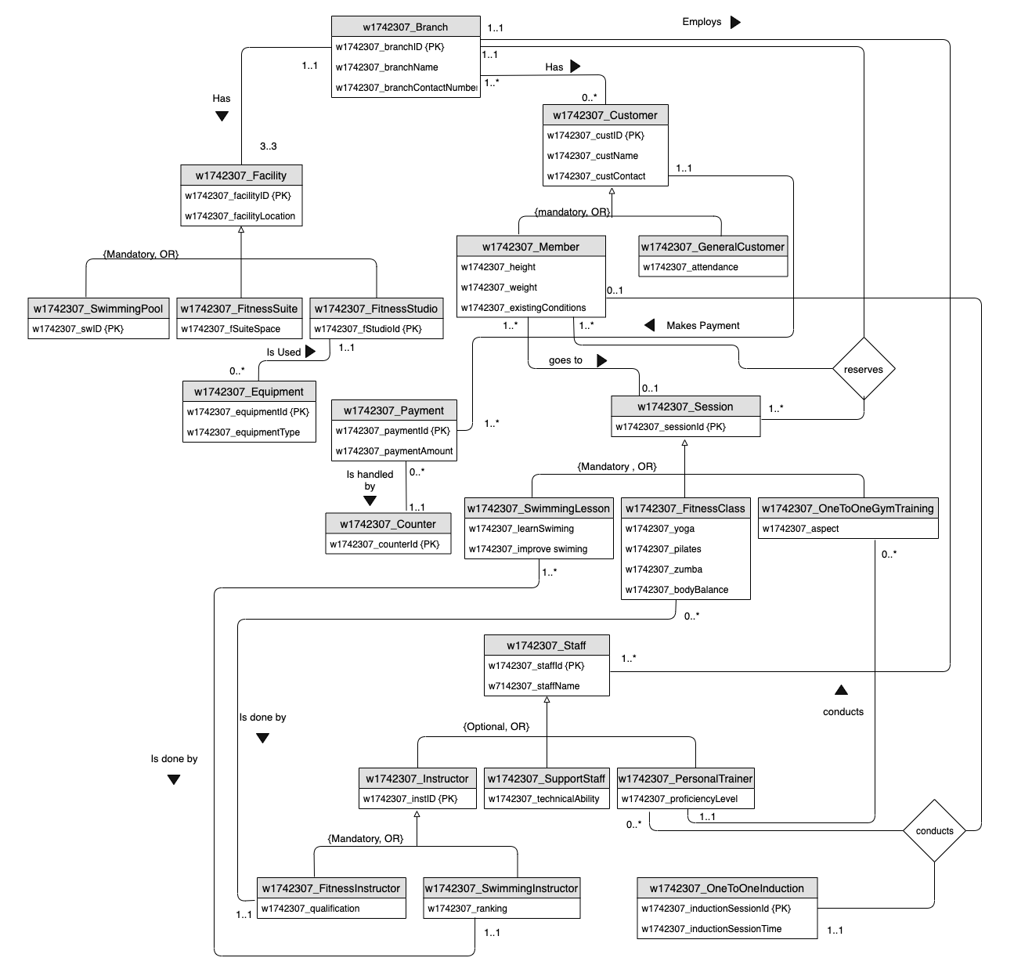

2.

|  |  |
| --- | --- |
| Entity name | Description |
| w1742307_Branch | To store data of the branch. |
| w1742307_Facility | To store information about the facilities in a branch. |
| w1742307_Equipment | To store information about the equipments. |
| w1742307_Customer | To store information about the customers. |
| w1742307_Payment | To store information about the payment that the customers make. |
| w1742307_Session | To store information about the sessions held at the branch. |
| w1742307_Staff | To store information about the staff. |
| w1742307_OneToOneInduction | To store induction information specific to customers such as equipment suggestion |

|  |  |  |
| --- | --- | --- |
| General entity | Specialised entity | Explanation |
| w1742307_Facility | w1742307_SwimmingPool |  |
|  | w1742307_FitnessSuite |  |
|  | w1742307_FitnessStudio |  |
| w1742307_Customer | w1742307_Member | Customers who purchased a membership get exclusive perks, therefore a special entity needed to store that infromation. |
|  | w1742307_GeneralCustomer | Customers who |
| w1742307_Session | w1742307_SwimmingLesson |  |
|  | w1742307_FitnessClass |  |
|  | w1742307_OneToOneGymTraining |  |
| w1742307_Staff | w1742307_Instructor |  |
|  | w1742307_SupportStaff | Support staff have specific jobs to do |
|  | w1742307_PersonalTrainer |  |
| w1742307_Instructor | w1742307_FitnessInstructor |  |
|  | w1742307_SwimmingInstructor |  |
|  |  |  |

3.

|  |  |  |  |  |  |
| --- | --- | --- | --- | --- | --- |
| Entity Name | Multiplicity | Relationship | Multiplicity | Entity name | Justification |
| w1742307_  Branch | 1..1 | Has | 3..3 | w1742307_  Facility |  |
|  |
|  |
|  |
| w1742307_  Equipment | 0..* | Is Used | 1..1 | w1742307_  FitnessStudio |  |
|  |
|  |
|  |
| w1742307_  Branch | 1..1 | Employs | 1..* | w1742307_  Staff |  |
|  |
|  |
|  |
| w1742307_  Branch | 1..* | Has | 0..* | w1742307_  Customer |  |
|  |
|  |
|  |
| w1742307_  Customer | 1..1 | Makes | 1..* | w1742307_  Payment |  |
|  |
|  |
|  |
| w1742307_  Member | 1..* | Goes to | 0..1 | w1742307_  Session |  |
|  |
|  |
|  |
| w1742307_  Payment | 0..* | Is handled by | 1..1 | w1742307_  Counter |  |
|  |
|  |
|  |
| w1742307_  FitnessClass | 0..* | Is done by | 1..1 | w1742307_  FitnessInstructor |  |
|  |
|  |
|  |
| w1742307_  Swimming  Lesson | 1..* | Is done by | 1..1 | w1742307_  Swimming  Instructor |  |
|  |
|  |
|  |
|  |
|  |
|  |

|  |  |  |  |  |  |  |  |
| --- | --- | --- | --- | --- | --- | --- | --- |
| Entity Name | Multiplicity | Entity  Name | Multiplicity | Entity Name | Multiplicity | Relationship | Justification |
| w1742307_  Branch | 1..1 | w1742307_  Member | 1..* | w1742307_  Session | 1..* | Reserves |  |
|  |
|  |
|  |
|  |
|  |
| w1742307_  Member | 0..1 | w1742307_  Personal  Trainer | 0..* | w1742307_  OneTo  One  Induction | 1..1 | Conducts |  |
|  |
|  |
|  |
|  |
|  |

4.

|  |  |  |
| --- | --- | --- |
| Entity Name | Attributes | Justification |
| w1742307_Branch | w1742307_branchID {PK},  w1742307_branchName,  w1742307_branchContactNumber |  |
| w1742307_Facility | w1742307_facilityID {PK},  w1742307_facilityLocation |  |
| w1742307_Equipment | w1742307_equipmentId {PK},  w1742307_equipmentType |  |
| w1742307_Payment | w1742307_paymentId {PK},  w1742307_paymentAmount |  |
| w1742307_Customer | w1742307_custID {PK},  w1742307_custName,  w1742307_custContact |  |
| w1742307_Session | w1742307_sessionId {PK} |  |
| w1742307_Staff | w1742307_staffId {PK},  w1742307_staffName |  |
| w1742307_OneToOneInduction | w1742307_inductionSessionId {PK},  w1742307_inductionSessionTime |  |
| w1742307_Counter | w1742307_counterId {PK} |  |
| w1742307_SwimmingPool | w1742307_swID {PK} |  |
|  |  |  |